Impressionism vs Neoclassicism: Tracing the Evolution of Modern Art
The evolution of modern art reflects profound shifts in style, theme, and artistic philosophy. Neoclassicism, epitomized by Jacques-Louis David’s Oath of the Horatii, and Impressionism, exemplified by Mary Cassatt’s Little Girl in a Blue Armchair, stand as landmarks in this transformation. This discussion examines the stylistic and thematic contrasts between these two works and explores the claim that Impressionism represents the first truly modern art style.

Neoclassicism: Order, rationality, and civic virtue
David’s Oath of the Horatii is a masterwork of Neoclassicism, the dominant artistic language of late eighteenth-century France. The painting is defined by crisp outlines, sculptural precision, and a disciplined composition structured around three architectural arches (Pollitt & Januszcak, 2015). David’s use of muted earth tones and Roman-inspired reds reinforces the classical setting, while the lighting directs attention to the central act of oath-taking. Thematically, the painting presents a dramatic narrative from Roman legend, focusing on heroic patriotism and the tension between duty and emotion. The men, embodying rational heroism, pledge loyalty to Rome above personal interests, while the women mourn the inevitable tragedy (Pollitt & Januszcak, 2015). This moral clarity and emphasis on civic virtue reflect Enlightenment ideals, positioning Neoclassicism as a vehicle for propagating reason and moral strength.
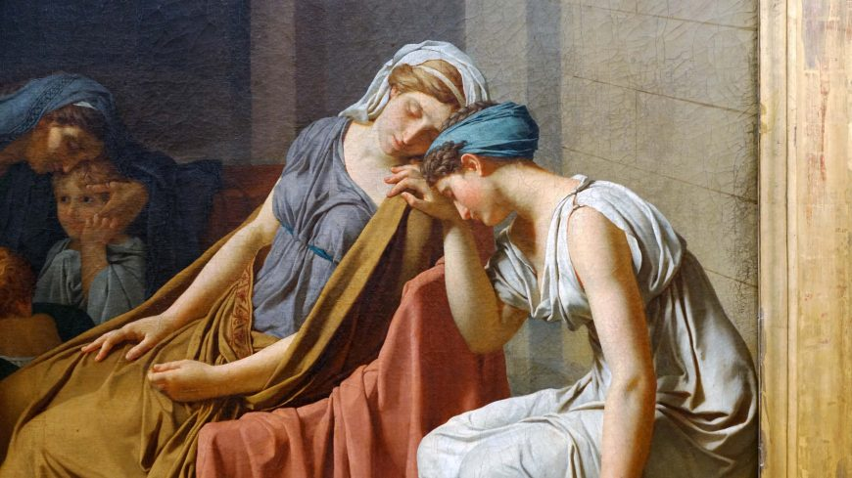
Detail, Jacques-Louis David, Oath of the Horatii, 1784, oil on canvas, 3.3 x 4.25 m, painted in Rome, exhibited at the salon of 1785 (As cited in Pollitt & Januszcak, 2015)

Impressionism: Subjectivity, everyday life, and stylistic innovation
In contrast, Cassatt’s Little Girl in a Blue Armchair reveals the hallmarks of Impressionism. The painting captures a quiet, intimate domestic moment, using loose, visible brushstrokes that suggest rather than meticulously define forms (McCoy, 2025). Cassatt’s palette of soft blues and whites creates a harmonious and tranquil atmosphere, with light gently playing across surfaces. Rather than heroic narrative or moral drama, Cassatt focuses on the psychological presence of the child, conveying innocence and introspection. This attention to fleeting moments and subjective experience marks a radical departure from the grand themes of Neoclassicism (McCoy, 2025). The informal composition and suggestive technique reflect Impressionism’s commitment to portraying modern life as it is lived, prioritizing immediacy and personal perception over idealized representation.
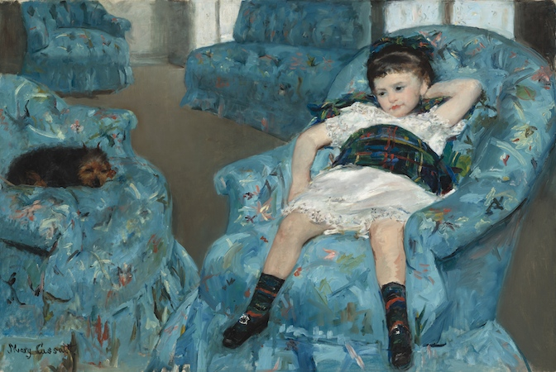
Mary Cassatt, Little Girl in a Blue Armchair, 1878, oil on canvas, 89.5 x 129.8 cm (As cited in McCoy, 2025)

Comparative discussion: technique, subject matter, and artistic intent
The stylistic evolution between Neoclassicism and Impressionism is evident in both technique and intent. David’s work is characterized by clarity, order, and narrative structure; every element serves the purpose of reinforcing civic ideals and moral lessons. Cassatt, however, dissolves rigid boundaries in favor of fluidity and spontaneity, inviting viewers into the subjective realm of everyday experience. While Neoclassicism looks to antiquity for models of virtue and permanence, Impressionism embraces the transience and contingency of modern existence. The shift from grand historical subjects to scenes of domestic intimacy signals a broader transformation in artistic priorities, from universal ideals to individual realities.

Modern art debate: Is Impressionism the first true modern art style?
The assertion that Impressionism is the first true modern art style is compelling, though it deserves nuanced consideration. Earlier movements such as Romanticism introduced expressive content and challenged classical norms, but Impressionism fundamentally redefined both the purpose and methods of painting. By abandoning linear perspective, precise outlines, and academic subject matter, Impressionists foregrounded perception, temporality, and the artist’s personal vision. Cassatt’s work embodies this shift, privileging immediacy and sensory experience (McCoy, 2025). In comparison, Neoclassicism, as exemplified by David, remains anchored in the traditions of the past, serving didactic and societal functions (Pollitt & Januszcak, 2015). Impressionism’s innovations in technique, subject matter, and artistic intention set the stage for subsequent modern art movements, including Post-Impressionism, Cubism, and Abstract Expressionism, each of which further challenged the boundaries of representation and meaning.

Conclusion
In summary, the contrast between David’s Oath of the Horatii and Cassatt’s Little Girl in a Blue Armchair illustrates the profound stylistic and thematic evolution that marks the transition to modern art. While Neoclassicism embodies order, rationality, and civic virtue through historical narrative, Impressionism inaugurates a new era of subjectivity, immediacy, and stylistic experimentation. Given its radical departure from academic conventions and its embrace of modern life, Impressionism can be convincingly regarded as the first true modern art style, laying the foundation for the diverse artistic explorations that followed.
References
McCoy, C. B. (2025). Jacques-Louis David, Oath of the Horatii. Smarthistory. https://smarthistory.org/jacques-louis-david-oath-of-the-horatii/
Pollitt B., & Januszcak W. (2015). Cassatt, Little Girl in a Blue Armchair. Khan Academy. https://www.khanacademy.org/humanities/becoming-modern/avant-garde-france/impressionism/a/cassatt-little-girl-in-a-blue-armchair

